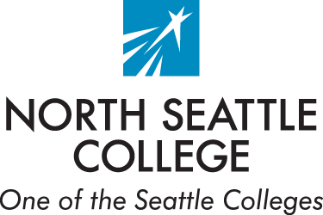
Disability Services
College Center Bldg, 2nd Floor
9600 College Way North
Seattle, Washington 98103-3599
Phone: (206) 934-3697
Email: ds@seattlecolleges.edu

Authorization for Release of Information
(Optional)

I, Click or tap here to enter text., Click or tap here to enter text.,
hereby authorize North Seattle College’s (NSC) Disability Services office to provide the below indicated individual(s) or institutional department with the following documents.

Documentation: (Please check all that apply).
☐Medical Documentation
☐NSC Letter of Accommodations

Individual(s) or institutional department receiving information:
Name: Click or tap here to enter text.
Address:Click or tap here to enter text.
City, State, Zip:Click or tap here to enter text.
Phone:Click or tap here to enter text.
Fax:Click or tap here to enter text.
Email:Click or tap here to enter text.
For the purpose of:Click or tap here to enter text.

Read before signing:
The NSC Disability Services office providing this information is hereby released from all legal responsibility or liability for the release of the above-mentioned information. I understand that this release document will remain active for any continued release requests until I explicitly request that it be voided. I acknowledge that my request to void this release will need to be in the form of a written, dated, and signed document submitted to the NSC Disability Services office.
Student Signature:Click or tap here to enter text. Date:Click or tap here to enter text.

